**Week 14**

Client-server network model

* Any process can act as serve or client. Depend on its ability of serving request to make it a server
* Client
* A remote process that request resource from another application process acting as server
* Server
* A process that return the requested resource as part of the response

Application

* DNS
* Used to resolve domain name into respective IP
* DNS client will always initiate a DNS request for a domain name requested by an application or user
* Upon receiving the request, DNS server will check the domain name with it zone records and send a DNS reply with the respective IP
* DHCP
* Used to assigning and managing IP to computer that connected to network
* A new connected PC (client) will always initiate a DHCP discover packet upon connection to the network
* The DHCP server upon receiving a discover packet from client will offer the first available IP to client using a DHCP offer packet
* DORA

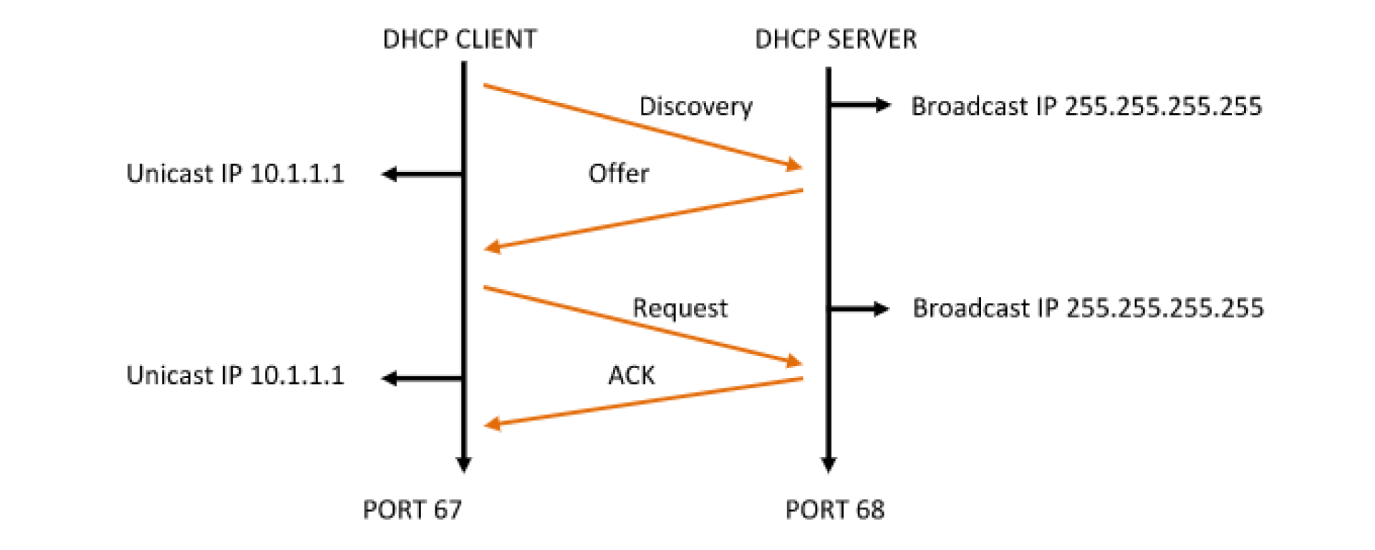

* Other
* AD
* SMTP
* HTTP

Protocol layer

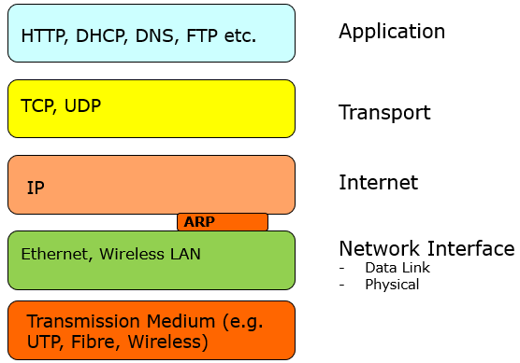

**Week 14**

Ethernet standards

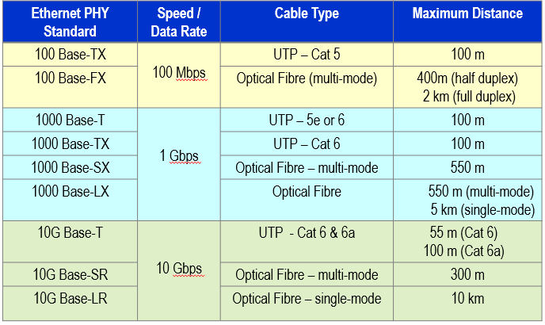

### Standard nomenclature

|  |  |
| --- | --- |
| Convention | Description |
| 100 Base T_ | Copper cabling |
| 10G Base _R  1000 Base _X (Where “_” is not “T”) | Fibre cabling |

Mac address

* 6 bytes length
* 6 pair hex digit
* Unique

Frame structure

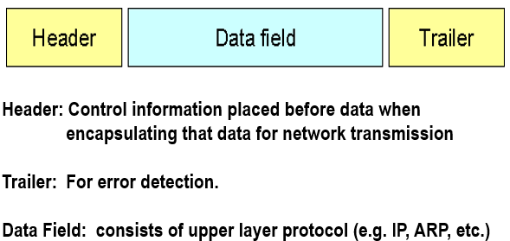

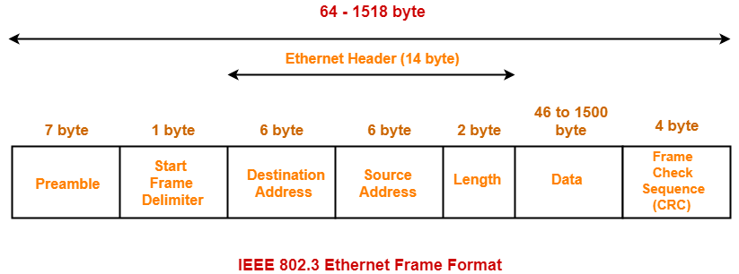

**Week 15**

Cable

* Twisted pair (copper cable)
* Shielded Twisted Pair (STP)
* A foil or wire braid “shield” is woven around a twisted pair; reduce noise rejection
* Unshielded Twisted Pair (UTP)
* A non “shielded” twisted pair
* Cheaper
* Connector
* RJ45
* Optical fibre
* Advantage over cooper cable
* Higher data rate
* Further transmission signal
* Resistance
* Immune to electrical interference (e.g. radio, motors)
* Maintenance
* Cost less to maintain; cost more upfront; no short-circuit
* Type
* Single mode
* Laser light
* Multi-mode
* LED light
* Connector
* ST
* Commonly use
* Multimode
* SC
* Commonly use
* Single-mode
* LC
* Single-mode

**Week16**

IPv4

* 32 bit length
* Made up of network ID and Host ID
* Subnet mask

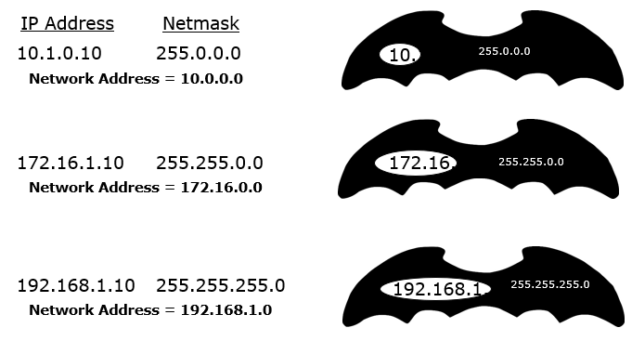

* Classes

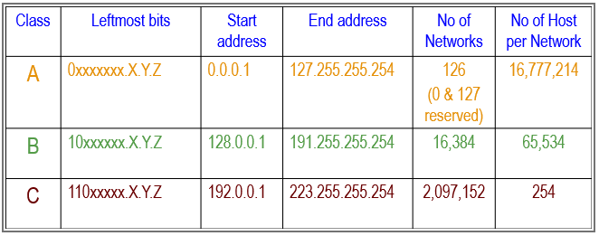

* Private address

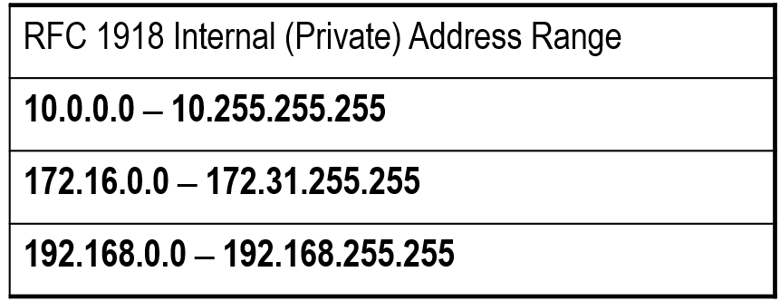

* First address (e.g. 192.168.0.0/24)
* Use as network ID
* Last address (e.g. 192.168.0.255/24)
* Broadcast address

NAT

* Use to connect a private network to internet
* By translating or mapping the private addresses to public addresses

TCP/UDP

* Application layer
* http
* port 80
* TCP
* https
* 443
* TCP
* Smtp
* Port 25
* TCP
* pop3
* port 110
* TCP
* dns
* port 53
* TCP / UDP
* ssh
* port 22
* TCP
* DHCP
* Port 67/68
* UDP

**Week 17**

WLAN

* Config
* SSID
* Freq. channel
* Security & encryption type
* WPA
* WPA2 personal
* WPA2 business
* Others config
* IP address.
* Subnet mask
* Gateway
* MAC address filter list